CYB 300 Module Three Lab Worksheet Two
Andree Salvo
Southern New Hampshire University
CYB 300
Intstructor: Jason Keltner

Lab: Install and Configure AD Certificate Services

Exercise 2: Configure Certificate Revocation Lists (CRLs)
Prompt | Response
Task 2: Take a screenshot of Step 3 showing the certificate revocation. Add your name to the command line. | There wasn’t a command line, so I added my name in CMD  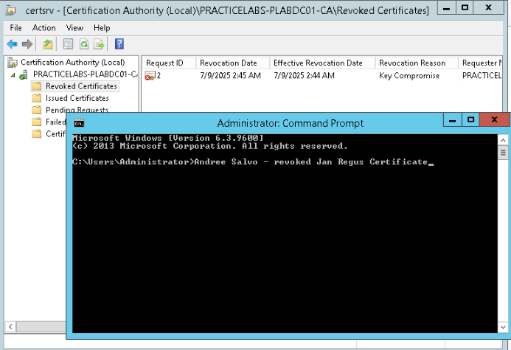

Exercise 3: Configure Active Directory Certificate Services Backup and Recovery
Prompt | Response
Task 2: Provide a screenshot of Step 3 showing the backup of CA and CA config file. Add your name to the command line. | 